**Last user creation**

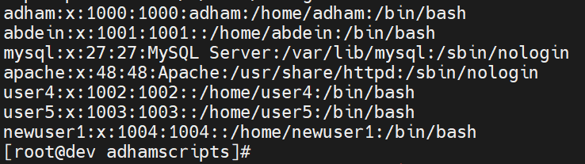

$6



